GENERAL CONDITIONS OF THE SHOW

- THE SHOW ORGANISER RESERVES THE RIGHT TO VARY THE ORDER OF EVENTS AND TIMES AND TO DECLINE ANY ENTRY.
- INSTRUCTIONS DISPLAYED OR GIVEN ON OR IN THE VICINITY OF THE SHOW GROUND MUST BE STRICTLY ADHERED TO.
- THE JUDGES DECISION IS FINAL.
- ALL COMPETITORS ARE EXPECTED TO CONDUCT THEMSELVES CORRECTLY AND SAFELY WITHIN THE RING, FAILURE TO DO SO AFTER ONE WARNING BY THE JUDGE OR RING STEWARD WILL RESULT IN THE COMPETITOR BEING REQUIRED TO LEAVE THE RING.
- AGES WILL BE TAKEN AS AT THE DAY OF THE SHOW. IN CASE OF A DISPUTE THE DRIVERS BIRTH CERTIFICATE AND/OR THE HORSE/PONY’S HEIGHT CERTIFICATE MAY BE REQUIRED AND PRIZES MAY BE WITHHELD. YOUNG DRIVERS MUST NOT HAVE ATTAINED THEIR 22nd BIRTHDAY BY THE DATE OF THE SHOW.
- NO MONEY WILL BE REFUNDED UNLESS A VETERINARY CERTIFICATE IS PRODUCED.
- PLEASE DO NOT LEAVE ANY RUBBISH, LITTER BEDDING OR MANURE ON THE SHOW GROUND.
- FOR ALL RIDDEN CLASSES HARD HATS TO THE APPROVED STANDARD MUST BE WORN, WITH THE CHIN STRAP FASTENED.
- ALL DRIVERS/GROOMS/PASSENGERS UNDER THE AGE OF 14 YEARS MUST WEAR A CORRECTLY FITTED HARD HAT WHEN IN A CARRIAGE OR IN ATTENDANCE TO A TURNOUT. THEY MUST MEET THE CURRENT BSI STANDARD AND BE PROPERLY FASTENED.
- ALL COMPETITORS AND OWNERS MUST BE CURRENT BDS MEMBERS
- GROOMS ARE NOT REQUIRED TO RIDE WITHIN THE VEHICLE.
- ALL CUPS ARE PERPETUAL AND MUST BE RETURNED CLEAN PRIOR TO THE 2018 SHOW.
- .PLEASE PARK IN AREA ALLOCATED ONLY.
- ALL VEHICLES MUST BE OF PROPER CONSTRUCTION - NO MOTOR CYCLE /CAR WHEELS PERMITTED.

.

Affiliated driving classes
Classes will commence at 11am
Entry for ALL Classes £7.00
Entries on the day as above plus £2.00
CLASS 1 | LONG REINING – Horses, Ponies and Donkeys 4 years and over. a chance to show off your skills by steering round a fun course. Blinkers or open bridles acceptable.
CLASS 2 | SMALL PONIES and DONKEYS Single or any combination up to maximum height of 11.3 hh and 4 Years or over to any style vehicle except wagons. Competitors to demonstrate the obedience and flexibility of turnout by successfully completing tasks set by the Judge.  Special Rosettes to the highest placed pony under 10hh and the smallest Donkey.
CLASS 3 | NOVICE HORSE, PONY, MULE or DONKEY Single or pair 4 years or over driven to any vehicle except a Hackney show wagon. must not have been placed first in ANY type of driving competition before April 1st 2017. Each turnout will be asked to perform a simple show to demonstrate basic driving skills and obedience.
CLASS 4 | EXERCISE VEHICLE – ANY HEIGHT Single, pair or tandem horse (s) or pony (s) mule (s) or Donkey (s) 4 years or over driven to a utility or pneumatic wheeled vehicle two or four wheeled only ( no traditional vehicles) Vehicles must be clean, tidy and safe suitable for everyday driving across mixed terrain. Pony/horse/mule must be correctly harnessed and spares must be carried. Whips should be appropriately dressed. This will be judged under BDS rules and the class may be split at the Judges and or Show Secretary’s discretion depending on entries.  Special Awards will also be given to:-  - Highest placed Young Driver  - Highest placed Disabled Whip
CLASS 5  CLASS 5a | YOUNG DRIVER -10 to 21 years of age  All turnouts must be accompanied by a suitably experienced and active adult. Whips will be judged on their ability to handle the reins, and to safely drive their turnout to a short test set by the judge. Vehicles may be traditional or exercise but the turnout should be clean and tidy and whips correctly dressed.  NOT BEFORE 1.30P.M.  PLEASURE DRIVING CLASS (Open) Single pair or tandem Horses, Ponies, mules and Donkeys 4 Years or over to any style vehicle except wagon. Competitors to demonstrate the obedience and flexibility of turnout by successfully completing tasks set by the judge. The class will assemble for preliminary judging and will be required to undertake tasks often encountered on a normal drive out. Marks will be accumulated and taken into account for the final judging.  All Competitors will receive a rosette kindly sponsored by Carriage Driving Magazine.
CLASS 6  CLASS 7 | PRIVATE DRIVING CLASS UNDER 13.2 and OVER 13.2 for Single, pair or tandem horse (s) or pony (s) 4 years or over harnessed to a well maintained vehicle suitable for an amateur to drive on the road, as a single, tandem or pair. Spares will be required to be shown. Commercial and Hackney wagons barred. This will be judged under BDS rules and the class may be split at the Judges and or Show Secretary’s discretion depending on entries.  PRIVATE DRIVING CLASS DONKEYS and MULES for Single, pair or tandem) 4 years or over harnessed to a well maintained vehicle suitable for an amateur to drive on the road, as a single, tandem or pair. Spares will be required to be shown. Commercial and Hackney wagons barred. This will be judged under BDS rules and the class may be split at the Judges and or Show Secretary’s discretion depending on entries.
CLASS 8 | PRIVATE DRIVING CLASS OPEN with drive  Single, pair or tandem horse (s) or pony (s) mule (s) or Donkey (s) 4 years or over harnessed to a well maintained vehicle suitable for an amateur to drive on the road, as a single, tandem or pair. Spares may be required to be shown. Commercial and Hackney wagons barred. This will be judged under BDS rules and the class may be split at the Judges and or Show Secretary’s discretion depending on entries. After preliminary judging there will be a drive of not less than 4 miles those successfully completing the drive will receive a BDS Show drive Rosette  The winner will be awarded the Jim Perrett Perpetual Challenge  Special Awards will be given to the highest placed exercise vehicle

North Wiltshire and Gloucestershire BDS
Would like to thank Perry Bishop and Chambers for kindly sponsoring the photocopying of all the schedules

Welcome to the Area’s Autumn Carriage Driving Show

This is the last show of the season at our NEW venue we have moved from the very top of Gloucestershire to the very bottom. It is open to any equine ( not sure about zebras!) the chance to just have fun, but receive a rosette as well, there are lots of different classes which hopefully will suit everyone. We have plenty of space so ideal for novices both human and equine.

It is the last Show before Addington so an opportunity for a final practice and there will of course be a road drive to provide the last of the possible chance to get your eighth rosette towards the eight required for your Red Rover Award. I do hope that Members in adjoining Areas will take the chance to join us.

Please note that entries can only be accepted from Whips who are current BDS members.

Have a safe journey

Hazel Woodbridge
Area Commissioner
North Wiltshire and Gloucestershire BDS

Directions

To Follow

Please ensure that you remove all evidence of your visit in the usual manner.

SECRETARY: Mrs HAZEL WOODBRIDGE
HAFAWEY HOUSE
HOGGS LANE
PURTON, SWINDON, WILTSHIRE
SN5 4BU

☎ 01793 770862
mobile 07962 977771

Closing date September 12th 2017

Please complete the enclosed entry form and return ASAP
Entries will be accepted on the day at an additional charge of £2 per class

Cheques should be made payable to N.Wilts & Glos Area BDS

Only valid current BDS members will be eligible to enter

,

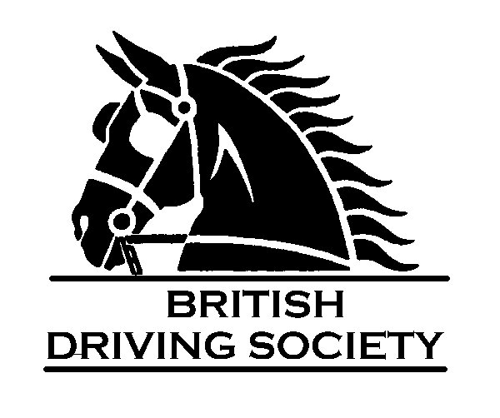

North Wiltshire and Gloucestershire Area

AUTUMN AREA BDS DRIVING SHOW

SUNDAY SEPTEMBER 17th 2017
At
Swallows Nest
Old Gloucester Road
Winterbourne
South Gloucestershire BS36 1RT

By kind invitation of Carole and Russ Baker

Judge Mrs Heather Noad

